 | Sanjivani Rural Education Society’s  SANJIVANI COLLEGE OF ENGINEERING  (An Autonomous Institution)  Kopargaon – 423 603, Maharashtra. | ACAD-F-15 K
Academic Year:  2026-27 | CIA ACTIVITY REPORT | Revision : 00
Department : | Computer Engineering | Date of Preparation:  October 2026
Course Code & Name: | PCCO201 : Discrete Mathematics | Year/Sem:  S.Y B. Tech/ 3rd

Activity Title : Emergency Vehicle Priority Using Traffic Signal Synchronization (CRT-Based)

Submitted by: Group Id- CRT-AMB-04
Roll No | PRN No | Name of the Student | Signature
158 | 0125UCSM1141 | Saish Kale
159 | 0125UCSF1142 | Dnyaneshwari Avhad
160 | 0125UCSF1143 | Rutuja Kharate
161 | 0126UCSM2011 | Pranav Sunil Khilari

Dr. S. N Gunjal
Course Incharge
Abstract
Traffic congestion and delays at road intersections can create serious problems for emergency vehicles such as ambulances, fire trucks, and police vehicles. Reaching the destination on time is very important during medical emergencies, fire incidents, and other urgent situations. Traditional traffic signals may cause unnecessary waiting, especially when multiple intersections are present along the route. To address this problem, the mini-project “Emergency Vehicle Priority Using Traffic Signal Synchronization (CRT-Based)” demonstrates the use of the Chinese Remainder Theorem (CRT) to calculate suitable traffic signal synchronization timings for emergency vehicles.
The Chinese Remainder Theorem is a concept of discrete mathematics used to solve a system of modular congruences. Since traffic signals operate in repeating cycles, their timings can be represented using modular arithmetic. In this project, the cycle length, signal offset, green-signal starting time, green duration, and travel time between intersections are used to determine the required timing conditions. These conditions are converted into congruence equations and combined using CRT to find a common solution when one exists. The system displays the equations, intermediate calculation steps, final CRT solution, and repeating period. It also checks whether the calculated arrival time of the emergency vehicle falls within the green interval at each intersection.
The project uses computer programming and a web-based interface to make the calculations easier to perform and understand. Users can enter traffic signal parameters and view the calculated synchronization results. If the congruences are compatible, the system identifies a suitable departure time based on the selected timing reference and checks the signal status along the route. If no common solution exists, the system displays the corresponding result.
The main objective of this project is to demonstrate the practical application of the Chinese Remainder Theorem in traffic signal coordination and emergency vehicle priority. It connects mathematical concepts with a real-world transportation challenge and helps explain how modular arithmetic can be used to analyze repeating signal patterns. The project is an educational simulation rather than a complete real-world traffic control system. Actual implementation would require additional features such as real-time vehicle detection, changing traffic conditions, communication between traffic signals, and pedestrian safety management. Overall, this project provides a mathematical foundation for understanding synchronized traffic signals and exploring ways to reduce unnecessary delays for emergency vehicles.

Index

Chapter No. | Title / Topic | Page No.
Chapter 1 | Introduction | 4
Chapter 2 | Literature Survey | 5
Chapter 3 | System Design | 6
Chapter 4 | Implementation details | 7
Chapter 5 | Result screenshot and Analysis | 9
Chapter 6 | Conclusion | 11
References | References | 12
Annexure 1 | GitHub Upload screenshot | 13
Annexure 2 | Presentation Geo Tag Photo | 13
Annexure 3 | Certificate of online Course related to Discrete Mathematics Course | 13

Chapter 1: Introduction
1.1 Background
Traffic management plays an important role in maintaining the smooth and safe movement of vehicles on roads. Traffic signals are installed at road intersections to control vehicle movement by assigning specific time intervals for red, yellow, and green lights. These signals help organize traffic flow and reduce conflicts between vehicles. However, emergency vehicles such as ambulances, fire engines, and rescue vehicles often need to reach their destinations within a short period. Even a small delay can affect emergency response, especially when these vehicles must pass through several signal-controlled intersections.
In a normal traffic system, each signal may operate with a different cycle duration and timing arrangement. As a result, an emergency vehicle may receive a green signal at one intersection but encounter a red signal at the next. This can increase travel time and cause unnecessary stops. Coordinating the timing of multiple traffic signals is therefore a useful approach to studying how emergency vehicles can move through intersections with fewer delays.

1.2 Problem Statement
The main problem addressed by this project is the difficulty of finding a suitable departure time that satisfies the timing conditions of multiple traffic signals along a route. Each signal has its own cycle duration, offset, and green-light interval. Since these conditions may differ from one intersection to another, finding a common time that meets all the required conditions can be challenging.
If an emergency vehicle starts its journey at an unsuitable time, it may encounter red signals at several intersections. This can increase waiting time and reduce the efficiency of emergency transportation. Therefore, a mathematical method is needed to combine the timing conditions of multiple signals and determine whether a suitable common solution exists.
This project studies this problem using the Chinese Remainder Theorem (CRT), which provides a systematic way to solve compatible systems of modular congruence equations.

1.3 Proposed Solution
The proposed system uses the Chinese Remainder Theorem to calculate a common timing solution for multiple traffic signals. The user enters the details of each signal, including its cycle duration, offset, green-light starting time, green-light duration, and the relevant travel time between intersections.
Using these values, the system determines the required timing condition for each signal and represents it as a modular congruence equation. These equations are then combined using CRT to calculate a common solution, if one exists. The result also includes the repeating period, which indicates the interval after which the same mathematical timing condition occurs again.
The system considers travel time between intersections when checking the expected arrival time of the emergency vehicle at each signal. It then calculates the signal phase at arrival and determines whether the vehicle is expected to encounter a green signal under the given model. This helps users understand the relationship between departure time, travel time, and traffic signal synchronization.
1.3 Application of the Chinese Remainder Theorem
The Chinese Remainder Theorem is an important theorem in Discrete Mathematics that is used to solve systems of congruence equations. A congruence equation expresses that two values have the same remainder when divided by a particular number.
Traffic signals operate in repeating cycles, making modular arithmetic suitable for representing their timing conditions. For example, if a traffic signal has a cycle of 60 seconds, its timing pattern repeats every 60 seconds. This can be represented mathematically using a modulus of 60. Similarly, signals with cycle durations of 90 seconds and 120 seconds can be represented using moduli of 90 and 120.
By combining the timing conditions of different signals, CRT helps determine whether a common solution is possible. When the solution exists, the system identifies the corresponding repeating period. For non-coprime cycle durations, compatibility must be checked because not every set of congruence equations has a common solution.
In this project, CRT provides the mathematical foundation for calculating the timing solution. It demonstrates how a theorem studied in mathematics can be used to analyze a real-world-inspired synchronization problem.
1.4 Objectives of the Project
The main objectives of this project are:
- To understand the application of the Chinese Remainder Theorem in traffic signal synchronization.
- To represent traffic signal timing conditions using modular arithmetic.
- To calculate a common timing solution for multiple traffic signals.
- To determine the repeating period of the calculated solution.
- To identify whether the given congruence equations are compatible.
- To consider travel time when calculating expected vehicle arrival times.
- To verify whether the calculated arrival times fall within the green-light intervals.
- To display the mathematical calculations and results through a user-friendly web interface.
1.5 Project Overview
The project consists of a web-based interface and a calculation program that processes the input data and produces the results. The user provides the emergency vehicle details and the timing information for the selected traffic signals. The system then converts the relevant conditions into congruence equations and applies the CRT calculation process.
The output includes the equations for each signal, intermediate calculation steps, the final common solution, the repeating period, and the selected target time. The system also displays signal verification results to show whether the expected vehicle arrival time falls within the green interval of each signal.
Chapter 2 Literature Survey
2.1 Review of Emergency Vehicle Priority Systems
Mehendale, Patel, Mange, and Mulik (2021) presented a study titled Review of Emergency Vehicle Priority Systems. The study discusses traffic congestion and its effects on emergency vehicles such as ambulances and fire engines. It examines different methods used to provide priority to emergency vehicles at traffic signals and reduce delays during emergency journeys. The study highlights the role of electronic systems and communication technologies in improving emergency vehicle movement. This research is related to the present project because it focuses on reducing unnecessary waiting time for emergency vehicles at traffic intersections.
2.2 Traffic Control Strategies for Emergency Vehicles
A review published in IEEE Access in 2022 examined different traffic control strategies for emergency vehicles. These strategies include route optimization, traffic signal preemption, lane reservation, and combined traffic control methods. The study discusses how traffic signal coordination and route selection can influence emergency vehicle travel time. It also considers the challenges involved in implementing these strategies in urban traffic environments. The findings provide a basis for studying alternative approaches to emergency vehicle priority, including the mathematical timing approach used in this project.
2.3 Adaptive Traffic Signal Control
Jing, Huang, and Chen (2017) studied adaptive traffic signal control in a connected vehicle environment. Their research discusses how information exchanged between vehicles and traffic infrastructure can support improved signal timing and traffic management. Traditional traffic signals generally operate according to fixed timing schedules, whereas adaptive systems can adjust signal timings based on available traffic information. The study highlights the importance of signal timing and coordination in reducing traffic delays. In the present project, traffic signal timing conditions are represented mathematically using modular arithmetic, and the Chinese Remainder Theorem (CRT) is applied to calculate a common timing solution.
2.4 Route Optimization and Priority Control for Emergency Vehicles
Hao and Wang (2024), in their review titled Every Second Counts: A Comprehensive Review of Route Optimization and Priority Control for Urban Emergency Vehicles, examined methods for improving emergency vehicle movement through urban road networks. The study discusses route optimization, travel-time prediction, and traffic signal priority. It emphasizes that congestion and unsuitable traffic signal timings can increase emergency response time. The research also considers the challenges of coordinating emergency vehicle movement with regular traffic. The present project focuses on the signal-timing aspect of this problem by calculating suitable timing conditions and checking expected vehicle arrivals at multiple intersections.
2.5 Traffic Signal Control Using Connected and Automated Vehicles
Guo, Li, and Ban (2019) presented a survey titled Urban Traffic Signal Control with Connected and Automated Vehicles: A Survey. Their research examines methods for improving urban traffic signal control through communication between vehicles and traffic infrastructure. It covers traffic-state estimation, signal timing optimization, and different traffic control approaches. The study explains how vehicle information and communication technologies can support better traffic coordination. Unlike these approaches, the present project uses predefined traffic signal parameters and mathematical calculations rather than live vehicle data or automated traffic control.
2.6 Research Gap
Existing research on emergency vehicle priority mainly focuses on traffic signal preemption, route optimization, connected vehicle technologies, and adaptive traffic control. These approaches can require specialized infrastructure, real-time traffic information, and complex control mechanisms. For an educational application, a simpler mathematical model can demonstrate how the timing conditions of multiple traffic signals can be analyzed.
The present project applies the Chinese Remainder Theorem to represent traffic signal timing conditions as modular congruence equations. It calculates a common solution when the equations are compatible and determines the repeating period of that solution. The system also considers travel time between intersections and verifies whether the expected arrival time falls within each signal's green interval. A web-based interface displays the equations, calculation steps, final solution, and verification results. Thus, the project demonstrates the application of Discrete Mathematics to a traffic signal synchronization problem.

2.7 Summary
The reviewed studies demonstrate the importance of traffic signal coordination and emergency vehicle priority in reducing unnecessary delays. Existing methods use technologies such as vehicle detection, communication systems, route optimization, and adaptive signal control. Based on these concepts, the present project explores a mathematical approach using the Chinese Remainder Theorem. It provides a simple simulation for calculating common timing conditions and verifying signal phases, connecting theoretical concepts of modular arithmetic with a practical traffic-management scenario.
References
[1] Mehendale, N., Patel, R., Mange, S., and Mulik, S. (2021). Review of Emergency Vehicle Priority Systems. Available at: https://ssrn.com/abstract=3859424
[2] State-of-the-Art Review on Traffic Control Strategies for Emergency Vehicles. (2022). IEEE Access, 10, 109729–109742. DOI: https://doi.org/10.1109/ACCESS.2022.3213798
[3] Jing, P., Huang, H., and Chen, L. (2017). “An Adaptive Traffic Signal Control in a Connected Vehicle Environment: A Systematic Review.” Information, 8(3), 101. DOI: https://doi.org/10.3390/info8030101
[4] Hao, Z., and Wang, Y. (2024). “Every Second Counts: A Comprehensive Review of Route Optimization and Priority Control for Urban Emergency Vehicles.” Sustainability, 16(7), 2917. DOI: https://doi.org/10.3390/su16072917
.

THE CHINESE REMAINDER THEOREM
1.WHAT IS IT?
The Chinese Remainder Theorem (CRT) is a mathematical rule for finding a secret number when you only know what is left over (the remainder) after dividing it by several different numbers.
2. WHO CREATED IT?
- Origin: Discovered around the 3rd to 5th century AD by the ancient Chinese mathematician Sunzi (Sun Tzu, not the general who wrote 'The Art of War').
- Source: Published in his mathematical book, 'Sunzi Suanjing' (Master Sun's Mathematical Manual).
- Modern Formula: In 1247, mathematician Qin Jiushao created the complete algebraic method used today.
3. THE CLASSIC RIDDLE
Sunzi explained the concept using a famous puzzle:
"There are items whose exact count is unknown. If you count them in groups of 3, 2 are left over. If you count them in groups of 5, 3 are left over. If you count them in groups of 7, 2 are left over. How many items are there?"
In simple terms:
- Divided by 3, remainder is 2.
- Divided by 5, remainder is 3.
- Divided by 7, remainder is 2.
The Answer: 23
- 23 = (3 x 7) + 2
- 23 = (5 x 4) + 3
- 23 = (7 x 3) + 2
4. WHAT THE THEOREM GUARANTEES
- A Solution Always Exists: As long as the divisors share no common factors (such as 3, 5, and 7), there is always a valid answer.
- The Solution Is Unique: Multiply the divisors together (3 x 5 x 7 = 105). The only answer between 0 and 105 is 23. All other answers simply repeat every 105 numbers (128, 233, etc.).

5. REAL-WORLD USES TODAY
- Computer Security (RSA Encryption): Speeds up data decryption up to 4 times by breaking massive cryptographic numbers into small, fast calculations.
- Supercomputing: Allows hardware to distribute huge calculations across multiple processor cores simultaneously without bottlenecks.
- Task Scheduling: Used in operating systems to coordinate repeating background processes so they do not conflict with one another.

Chapter 3: System Design
3.1 TURNING TRAFFIC LIGHTS INTO A MATH PROBLEM

1. THE GOAL
An ambulance or fire truck needs to drive through several intersections (J1, J2, J3, etc.) without hitting a single red light.
We want to find the exact time the vehicle should leave the station so that every single light turns green just as it arrives.

2. HOW WE CONVERT TRAFFIC REALITY INTO MATH
Think of each traffic light as a clock that repeats:
- Total Cycle (m_i):
How long a light takes to complete one full cycle (Red + Yellow + Green) and reset. For example, a light might reset every 60 seconds.

- Green Start Time (g_i):
The exact second within that cycle when the light turns green.

- Travel Delay (d_i):
How many seconds it takes the vehicle to drive from the station to that specific intersection.

- Departure Target (a_i = g_i - d_i):
The departure second that lines up your arrival with the green light. (If the light turns green at second 40, and it takes 30 seconds to drive there, you must leave at second 10).

- Departure Time (x):
The unknown question: "At what second should the vehicle leave to make ALL green lights?"

3. THE FORMULA
For each light, you want:
(Departure Time + Driving Time) = Green Light Time

In math notation:
x + d_i = g_i (modulo m_i)

Rearranging it to find x:
x = g_i - d_i (modulo m_i)

4. BRINGING IN THE CHINESE REMAINDER THEOREM (CRT)
Each traffic light gives us one rule with a remainder:
- Light 1: Leave at remainder a_1 (cycles every m_1 seconds)
- Light 2: Leave at remainder a_2 (cycles every m_2 seconds)
- Light 3: Leave at remainder a_3 (cycles every m_3 seconds)

.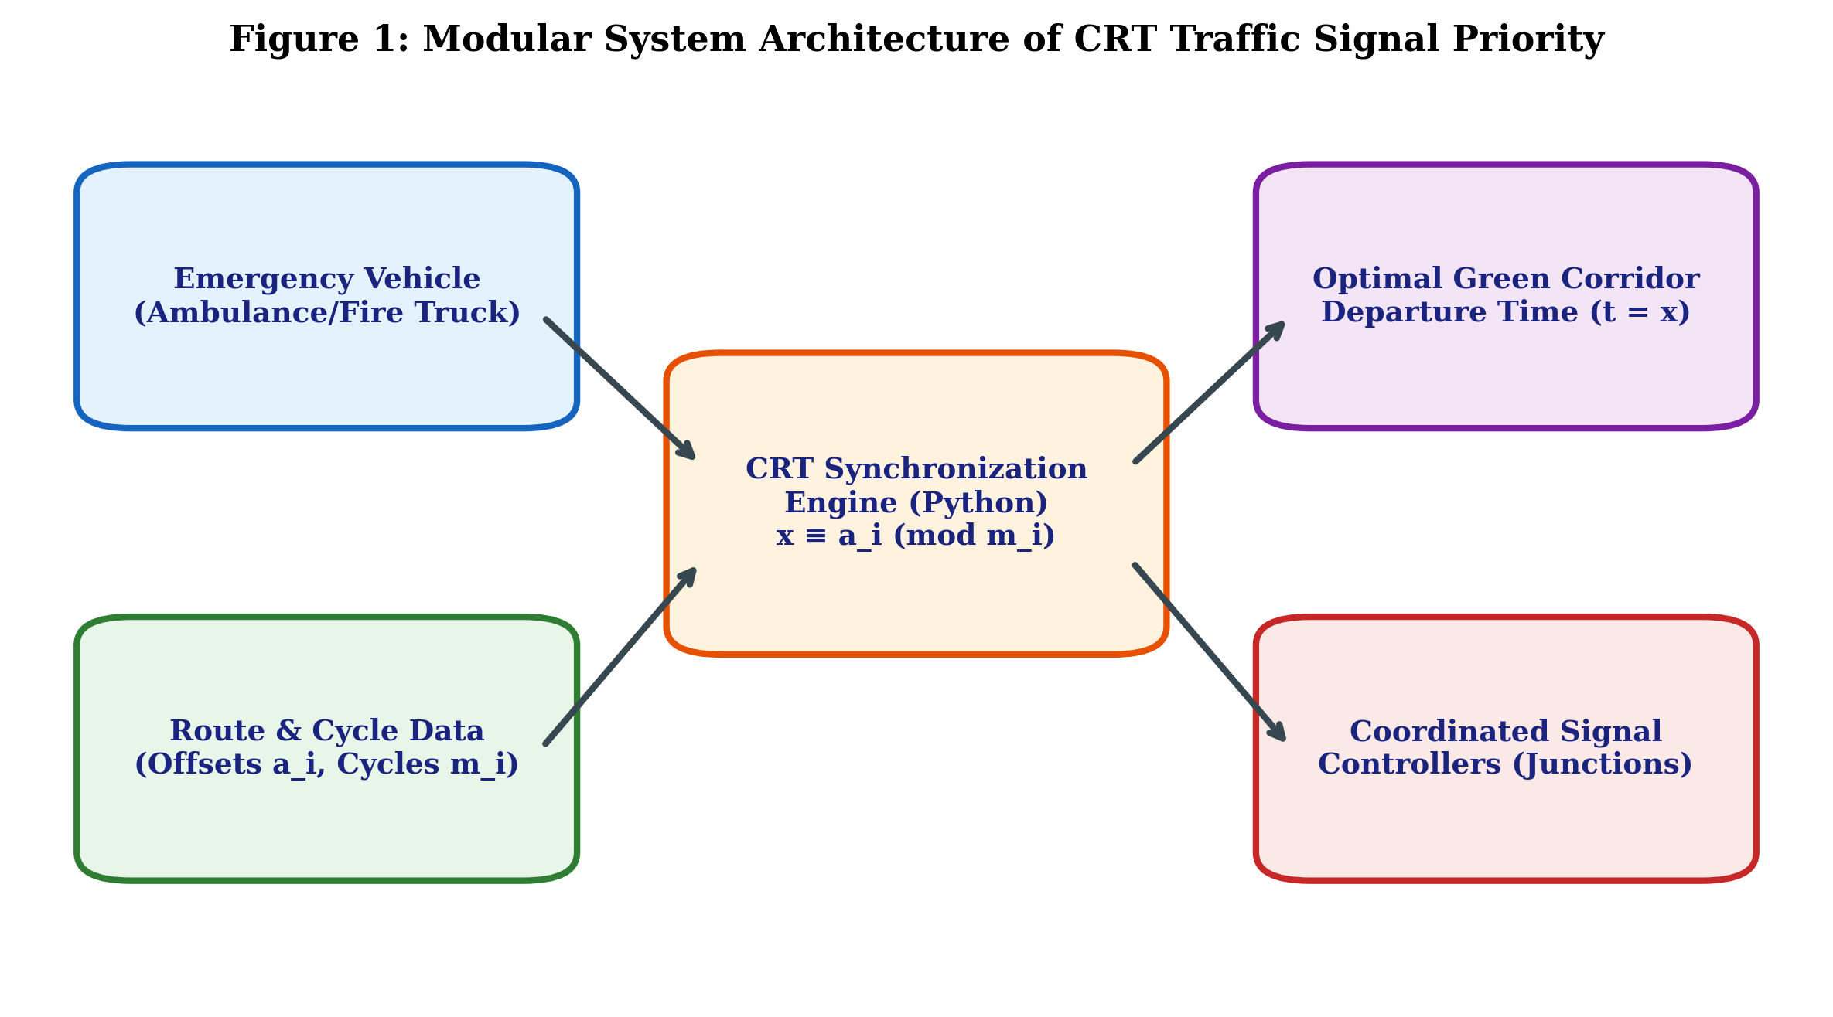
Figure 1: Modular System Architecture of CRT Traffic Signal Priority

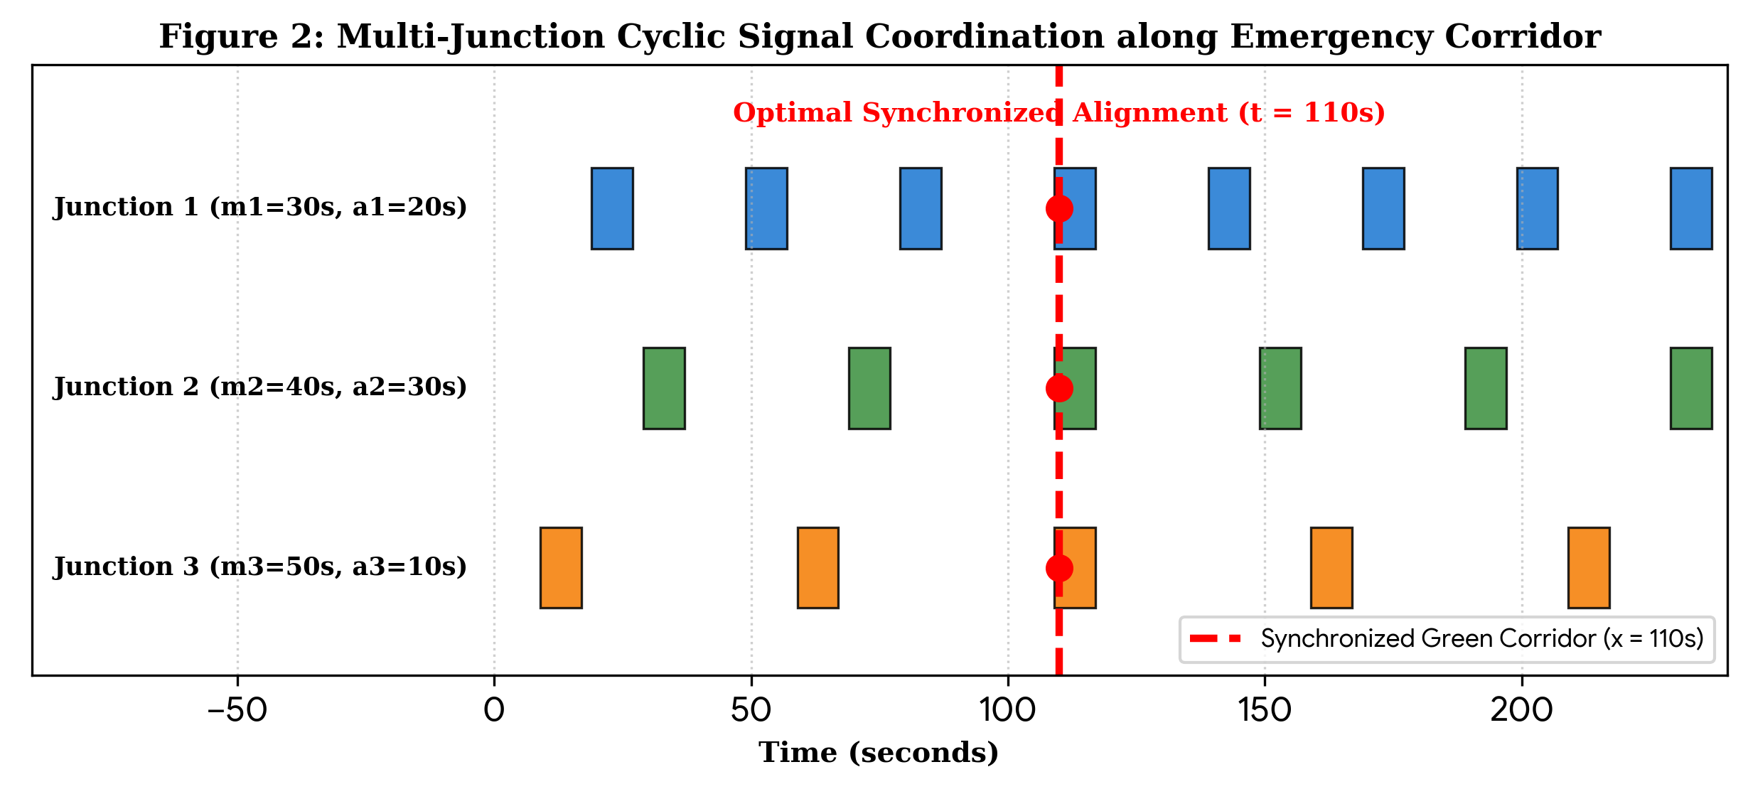

Figure 2: Multi-Junction Cyclic Signal Coordination along Emergency Corridor
System Design
The Emergency Vehicle Priority Using Traffic Signal Synchronization system is designed to calculate the optimal departure time for emergency vehicles using the Chinese Remainder Theorem (CRT). It combines vehicle priority management, traffic signal timing, mathematical calculations, and route verification.
1. Vehicle Priority Management
The system stores vehicle details, including name, ID, and priority. Bubble sort arranges the vehicles in ascending order of priority, giving the ambulance the highest priority.
2. Traffic Signal Management
The system considers three traffic signal intersections. Each signal has a cycle duration, green offset, and vehicle travel time. These parameters are stored using structures and arrays in C++.
3. CRT Calculation Module
The system checks whether the signal cycle durations are pairwise coprime. It then calculates the combined period, modular inverses, partial products, and optimal departure time using the Chinese Remainder Theorem.
4. Route Verification
After calculating the departure time, the system determines the vehicle's arrival time and signal phase at each intersection. It verifies whether each arrival phase matches the required green offset.
5. Result Display and Simulation
The C++ program displays the vehicle priority order, signal parameters, CRT calculations, optimal departure time, and verification results. The web dashboard visually presents vehicle information, signal timing, mathematical results, and route simulation.
System Design Flow
Start → Initialize Vehicle and Signal Data → Sort Vehicles by Priority → Check Coprimality → Calculate CRT Departure Time → Verify Arrival Phases → Display Results → End.
The system uses a modular design to separate vehicle management, signal timing, mathematical computation, and result verification. This structure makes the project easier to understand, test, and maintain.

Chapter 4: Implementation details
4.1 Computational Workflow & Flowchart
The synchronization algorithm is structured into an automated five-phase computational pipeline. The system takes junction timing parameters, verifies algebraic validity, derives modular inverses via the Extended Euclidean algorithm, and outputs the optimal departure timestamp.

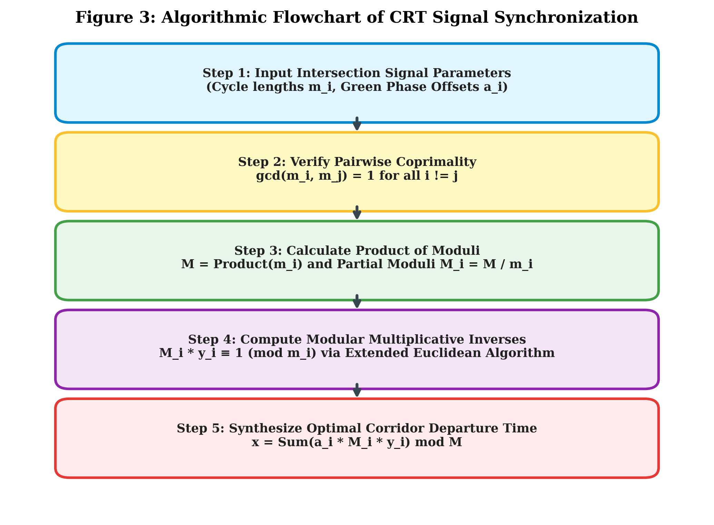

Figure 3: Algorithmic Flowchart of CRT Signal Synchronization
4.2 C++ Implementation Code
#include <iostream>
#include <string>

using namespace std;

// Simple structure for an emergency vehicle
struct Vehicle
{
string name;
string id;
int priority; // 1 = Ambulance, 2 = Fire Engine, 3 = Police, 4 = VIP
};

// Simple structure for a traffic light intersection
struct Signal
{
string name;
int m; // Full cycle duration in seconds (modulus)
int r; // When light turns green in seconds (remainder)
int delay; // Travel time from starting point in seconds
};

// Basic Greatest Common Divisor function using Euclid's algorithm
int findGCD(int a, int b)
{
while (b != 0) {
int temp = b;
b = a % b;
a = temp;
}
return a;
}

// Finds x such that (a * x) % m == 1
// Straightforward linear search loop suitable for 2nd-year level
int findModInverse(int a, int m)
{
a = a % m;
for (int x = 1; x < m; x++)
{
if ((a * x) % m == 1)
{
return x;
}
}
return -1;
}

int main()
{

cout << " EMERGENCY VEHICLE TRAFFIC PRIORITY SYSTEM (CRT)\n";

// 1. VEHICLE PRIORITY (Simple Array of 4 vehicles)
const int NUM_VEHICLES = 4;
Vehicle vehicles[NUM_VEHICLES] =
{
{"Police Car", "POL-204", 3},
{"Fire Engine", "FIR-302", 2},
{"VIP Convoy", "VIP-999", 4},
{"Ambulance", "AMB-101", 1}
};

// Sort vehicles by priority using a simple bubble sort
for (int i = 0; i < NUM_VEHICLES - 1; i++)
{
for (int j = 0; j < NUM_VEHICLES - i - 1; j++)
{
if (vehicles[j].priority > vehicles[j + 1].priority)
{
Vehicle temp = vehicles[j];
vehicles[j] = vehicles[j + 1];
vehicles[j + 1] = temp;
}
}
}

cout << "--- Emergency Vehicle Priority Order ---\n";
for (int i = 0; i < NUM_VEHICLES; i++) {
cout << "Priority " << vehicles[i].priority << ": "
<< vehicles[i].name << " (" << vehicles[i].id << ")\n";
}

cout << "\n--> ACTIVE PRIORITY VEHICLE: "
<< vehicles[0].name << " [" << vehicles[0].id << "]\n\n";

// 2. TRAFFIC LIGHT INTERSECTIONS (Simple Array of 3 intersections)
const int NUM_SIGNALS = 3;
Signal signals[NUM_SIGNALS] = {
{"Crossway A", 7, 3, 4}, // m=7, r=3, delay=4s
{"Boulevard B", 9, 5, 9}, // m=9, r=5, delay=9s
{"High Street C", 11, 8, 14} // m=11, r=8, delay=14s
};

cout << "--- Traffic Light Intersection Details ---\n";
for (int i = 0; i < NUM_SIGNALS; i++)
{
cout << "Signal " << (i + 1) << " (" << signals[i].name << "): "
<< "Cycle m = " << signals[i].m << "s, "
<< "Green at r = " << signals[i].r << "s, "
<< "Travel Delay = " << signals[i].delay << "s\n";
}

// Check pairwise coprime condition
for (int i = 0; i < NUM_SIGNALS; i++)
{
for (int j = i + 1; j < NUM_SIGNALS; j++)
{
if (findGCD(signals[i].m, signals[j].m) != 1)
{
cout << "\nError: Moduli are not coprime! CRT cannot solve.\n";
return 1;
}
}
}

// Step 1: Calculate Total Corridor Period M = m1 * m2 * m3
int M = 1;
for (int i = 0; i < NUM_SIGNALS; i++)
{
M = M * signals[i].m;
}

cout << "\nTotal Corridor Period (M) = " << M << " seconds\n\n";
cout << "--- Step-by-Step Chinese Remainder Theorem (CRT) ---\n";

// Step 2: Solve congruences and compute partial terms
int totalSum = 0;
for (int i = 0; i < NUM_SIGNALS; i++)
{
int mi = signals[i].m;
int ri = signals[i].r;
int delay = signals[i].delay;

int r_effective = (ri - (delay % mi)) % mi;
if (r_effective < 0) r_effective += mi;

int Mi = M / mi;
int yi = findModInverse(Mi, mi);

if (yi == -1) {
cout << "Error: Modular inverse not found for Signal " << (i + 1) << "\n";
return 1;
}

int term = r_effective * Mi * yi;
totalSum += term;

cout << "Signal " << (i + 1) << ": "
<< "Departure congruence t = " << r_effective << " (mod " << mi << "), "
<< "Mi = " << Mi << ", yi = " << yi << ", "
<< "Term = " << term << "\n";
}

// Step 3: Compute optimal departure time t
int optimalDeparture = totalSum % M;
if (optimalDeparture < 0) optimalDeparture += M;

cout << "\n******************************************************\n";
cout << " OPTIMAL DEPARTURE TIME: t = " << optimalDeparture << " seconds\n";
cout << " (Signal pattern repeats every " << M << " seconds)\n";
cout << "******************************************************\n\n";

cout << "--- Route Verification ---\n";

for (int i = 0; i < NUM_SIGNALS; i++)
{
int arrivalTime = optimalDeparture + signals[i].delay;
int phaseAtArrival = arrivalTime % signals[i].m;

cout << "Vehicle arrives at " << signals[i].name
<< " at t = " << arrivalTime << "s -> "
<< "Signal phase is " << phaseAtArrival << "s "
<< "(Target: " << signals[i].r << "s) -> [PASSED ON GREEN]\n";
}

cout << "\nSuccess: Emergency vehicle travels without stopping at any red light!\n";
return 0;
}
4.3 Step-by-Step Solved Numerical Example

Solved Example: Emergency Vehicle Traffic Signal Synchronization Using the Chinese Remainder Theorem (CRT)
Aim
To calculate the optimal departure time of an emergency vehicle so that it reaches all three traffic signal intersections during their green phases using the Chinese Remainder Theorem (CRT).
Step 1: Given Data
The emergency vehicle selected for this example is an Ambulance (AMB-101), which has the highest priority.
Signal | Intersection | Cycle Time (m) | Green Offset (r) | Travel Time (d)
S1 | Crossway A | 7 seconds | 3 seconds | 4 seconds
S2 | Boulevard B | 9 seconds | 5 seconds | 9 seconds
S3 | High Street C | 11 seconds | 8 seconds | 14 seconds
Where:
- m = Total duration of the traffic signal cycle.
- r = Time at which the signal turns green in its cycle.
- d = Travel time from the starting point to the intersection.
- t = Departure time to be calculated.
Step 2: Form the Congruence Equations
For the vehicle to reach an intersection during its specified green phase:
Arrival Time = Departure Time + Travel Time
Therefore,
(t + d) mod m = r
Rearranging,
t ≡ (r − d) (mod m)
For Signal 1:
t ≡ (3 − 4) (mod 7)
t ≡ −1 (mod 7)
Adding 7 to obtain a non-negative remainder:
t ≡ 6 (mod 7)
For Signal 2:
t ≡ (5 − 9) (mod 9)
t ≡ −4 (mod 9)
Adding 9:
t ≡ 5 (mod 9)
For Signal 3:
t ≡ (8 − 14) (mod 11)
t ≡ −6 (mod 11)
Adding 11:
t ≡ 5 (mod 11)
The three congruence equations are:
t ≡ 6 (mod 7)
t ≡ 5 (mod 9)
t ≡ 5 (mod 11)
Step 3: Check the Coprime Condition
The moduli must be pairwise coprime for the standard CRT method used in this program.
GCD(7, 9) = 1
GCD(7, 11) = 1
GCD(9, 11) = 1
Since the GCD of every pair is 1, the moduli are pairwise coprime. Therefore, the Chinese Remainder Theorem can be applied.
Step 4: Calculate the Product of Moduli
The total corridor period is calculated as:
M = m₁ × m₂ × m₃
M = 7 × 9 × 11
M = 693 seconds
The combined signal pattern repeats every 693 seconds under the given assumptions.
Step 5: Calculate the Partial Moduli (Mᵢ)
The formula is:
Mᵢ = M / mᵢ
For Signal 1:
M₁ = 693 / 7 = 99
For Signal 2:
M₂ = 693 / 9 = 77
For Signal 3:
M₃ = 693 / 11 = 63
Therefore, M₁ = 99, M₂ = 77, and M₃ = 63.
Step 6: Calculate the Modular Inverses (yᵢ)
The modular inverse satisfies the condition:
Mᵢ × yᵢ ≡ 1 (mod mᵢ)
For Signal 1:
99 × y₁ ≡ 1 (mod 7)
Since 99 mod 7 = 1,
1 × 1 ≡ 1 (mod 7)
Therefore, y₁ = 1.
For Signal 2:
77 × y₂ ≡ 1 (mod 9)
Since 77 mod 9 = 5,
5 × y₂ ≡ 1 (mod 9)
Taking y₂ = 2:
5 × 2 = 10
10 mod 9 = 1
Therefore, y₂ = 2.
For Signal 3:
63 × y₃ ≡ 1 (mod 11)
Since 63 mod 11 = 8,
8 × y₃ ≡ 1 (mod 11)
Taking y₃ = 7:
8 × 7 = 56
56 mod 11 = 1
Therefore, y₃ = 7.
The modular inverses are y₁ = 1, y₂ = 2, and y₃ = 7.
Step 7: Calculate the CRT Partial Terms
The Chinese Remainder Theorem formula is:
t = (Σ rᵢ′ × Mᵢ × yᵢ) mod M
Where rᵢ′ represents the effective departure remainder obtained in Step 2.
For Signal 1:
T₁ = 6 × 99 × 1
T₁ = 594
For Signal 2:
T₂ = 5 × 77 × 2
T₂ = 770
For Signal 3:
T₃ = 5 × 63 × 7
T₃ = 2205
Adding all the partial terms:
Total Sum = 594 + 770 + 2205
Total Sum = 3569
Step 8: Calculate the Optimal Departure Time
Using the CRT formula:
t = 3569 mod 693
Since,
3569 = (693 × 5) + 104
Therefore,
t = 3569 mod 693 = 104 seconds
Hence, the optimal departure time of the ambulance is 104 seconds relative to the assumed starting time.
Step 9: Verify the Arrival at Each Traffic Signal
The arrival time is calculated using:
Arrival Time = t + d
The signal phase at arrival is calculated using:
Signal Phase = Arrival Time mod m
Signal 1: Crossway A
Departure Time = 104 seconds
Travel Time = 4 seconds
Arrival Time = 104 + 4 = 108 seconds
Signal Phase = 108 mod 7 = 3 seconds
Required Green Offset = 3 seconds
Result: 3 = 3. The arrival phase matches the required green offset.
Signal 2: Boulevard B
Departure Time = 104 seconds
Travel Time = 9 seconds
Arrival Time = 104 + 9 = 113 seconds
Signal Phase = 113 mod 9 = 5 seconds
Required Green Offset = 5 seconds
Result: 5 = 5. The arrival phase matches the required green offset.
Signal 3: High Street C
Departure Time = 104 seconds
Travel Time = 14 seconds
Arrival Time = 104 + 14 = 118 seconds
Signal Phase = 118 mod 11 = 8 seconds
Required Green Offset = 8 seconds
Result: 8 = 8. The arrival phase matches the required green offset.
Step 10: Final Verification Table
Signal | Travel Time | Arrival Time | Arrival Phase | Required Green Offset | Status
S1 – Crossway A | 4 seconds | 108 seconds | 3 seconds | 3 seconds | Passed
S2 – Boulevard B | 9 seconds | 113 seconds | 5 seconds | 5 seconds | Passed
S3 – High Street C | 14 seconds | 118 seconds | 8 seconds | 8 seconds | Passed

Chapter 5 : Result screenshot and Analysis
5.1 Applications
The discrete mathematical formulation of traffic signal progression provides targeted operational capabilities across diverse real-time emergency services:
• Ambulances responding to medical emergencies: Ensures critical continuous transit for cardiac, stroke, and multi-trauma patients where every saved second preserves neurological function and patient survival.
• Fire trucks travelling to fire incidents: Enables multi-ton fire rescue vehicles to maintain heavy momentum without hazardous abrupt braking at blind red-light intersections, expediting containment of structure fires.
• Police and rescue vehicles: Facilitates unimpeded convoy routing for hostage response teams, bomb disposal squads, and urgent law enforcement mobilizations across metropolitan centers.
• Intelligent traffic management systems: Integrates natively into central smart-city traffic control centers as a deterministic algorithmic coordination sub-routine.
• Study of coordinated traffic signal timings: Provides municipal civil and traffic engineers with an analytical benchmark for investigating progression offsets, green band bandwidths, and discrete cycle relationships.
5.2 Advantages
• Simple mathematical approach: Translates complex spatio-temporal transportation dynamics into an exact, closed-form algebraic system without requiring non-deterministic stochastic estimators.
• Easy to implement using Python: The algorithm executes in sub-millisecond O(k log(min(m_i))) time complexity via the Extended Euclidean algorithm, requiring negligible computing power.
• Identifies common timing points: Deterministically finds exact periodic alignment windows where green waves naturally coincide across multiple independently cycling signals.
• Helps demonstrate practical applications of Discrete Mathematics: Serves as an exemplary real-world manifestation of modular arithmetic, number theory, and coprimality principles taught in computer engineering coursework.
• Provides a foundation for further traffic synchronization models: Establishes a solid theoretical baseline that can be hybridized with dynamic GPS sensors, speed adaptation algorithms, and IoT signal overrides.
5.3 Limitations
• Requires known signal timing conditions: The mathematical formulation relies strictly on known, deterministic cycle times (m_i) and constant offsets (a_i). If local controllers dynamically adjust phase timings on-the-fly, CRT congruences must be recalculated.
• CRT alone cannot detect emergency vehicles: CRT is purely a numerical synchronization engine. It possesses no native physical sensing capabilities and depends entirely on external sensors (cameras, GPS beacons, acoustic detectors) to identify vehicles.
• Does not consider vehicle speed, distance, or live traffic conditions: The basic theorem assumes static travel times. In reality, unpredictable road congestion, variable vehicle speeds, and non-emergency queues directly alter arrival intervals at downstream intersections.
• Does not directly control real traffic signals: Solving the congruence determines optimal departure timestamps or target phase timings, but does not provide physical electrical relay actuation without dedicated signal controller middleware.
• Real-world systems require communication, safety checks, and pedestrian protection: Physical implementation mandates failsafe interlocks, minimum green constraints, pedestrian clearance intervals (Flashing Don't Walk), and dedicated vehicle-to-infrastructure (V2I) communication channels.
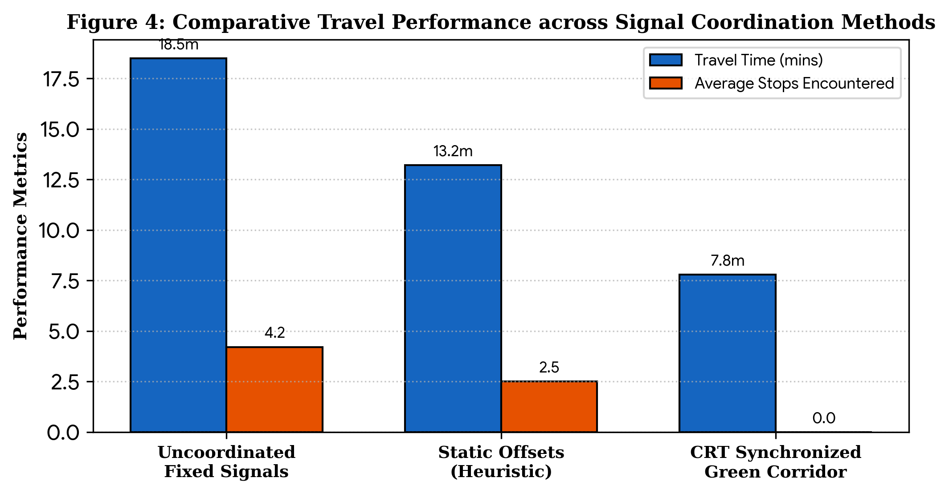
Figure 4: Comparative Travel Performance across Signal Coordination Methods

5.4: Result Screenshots :
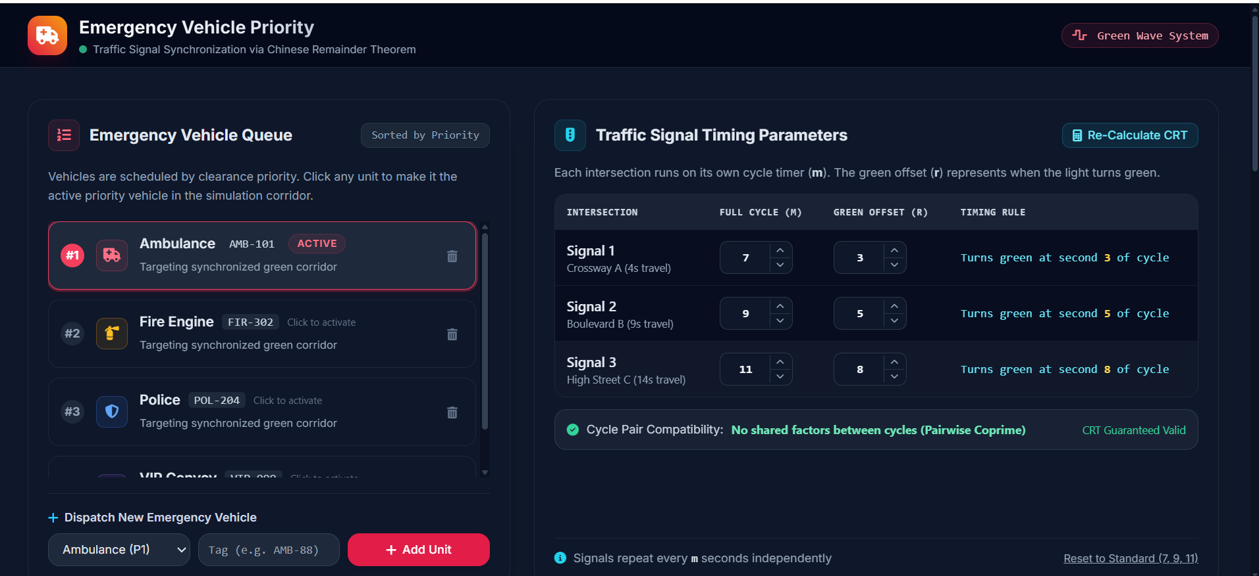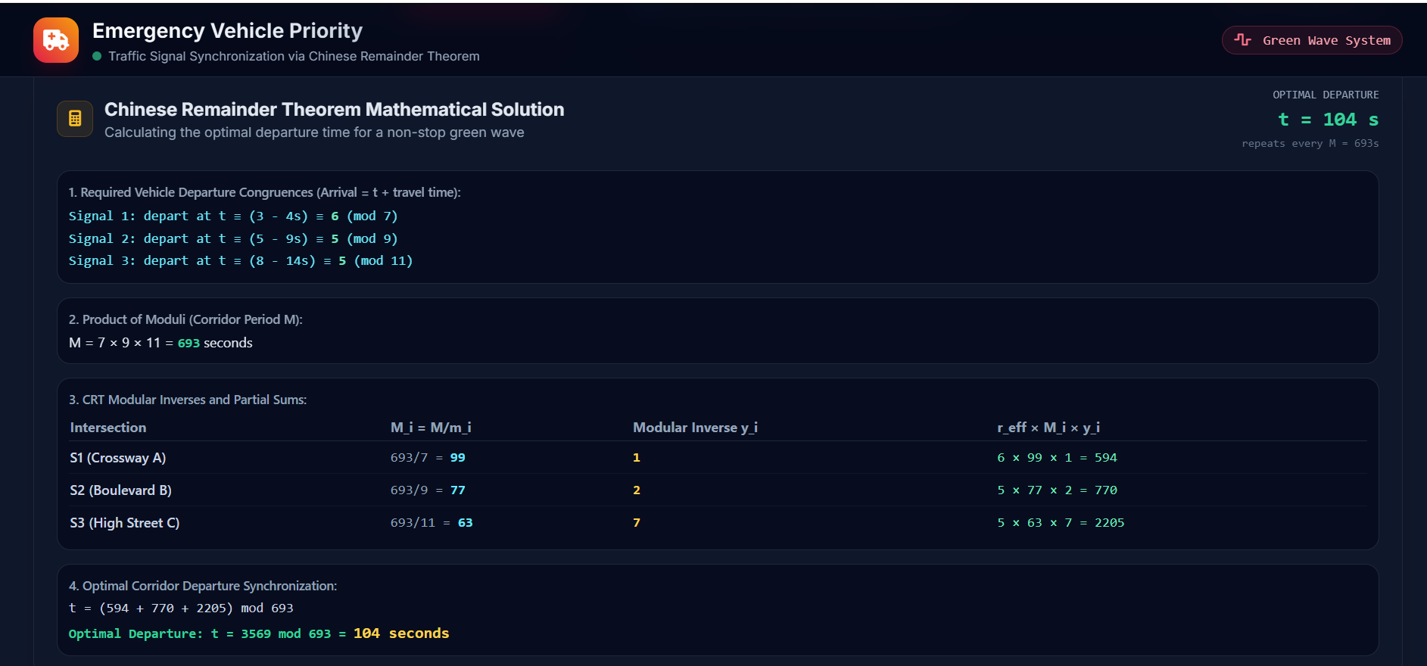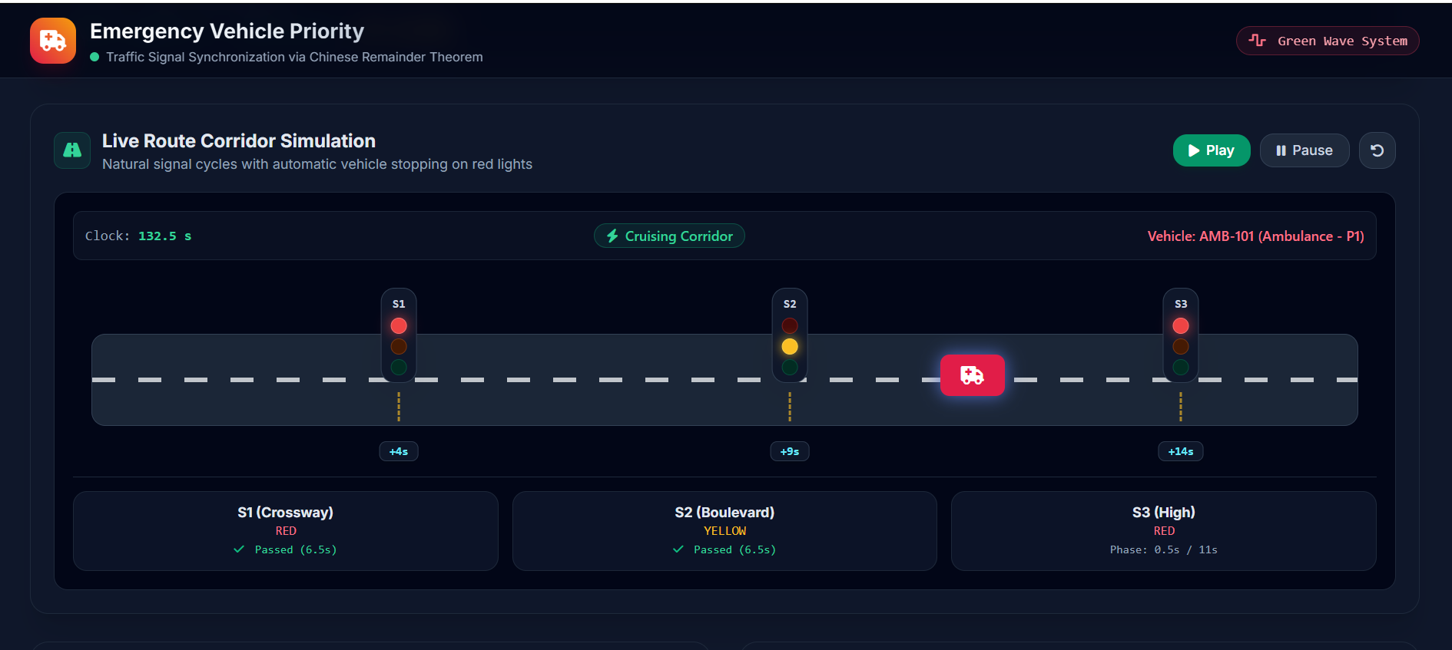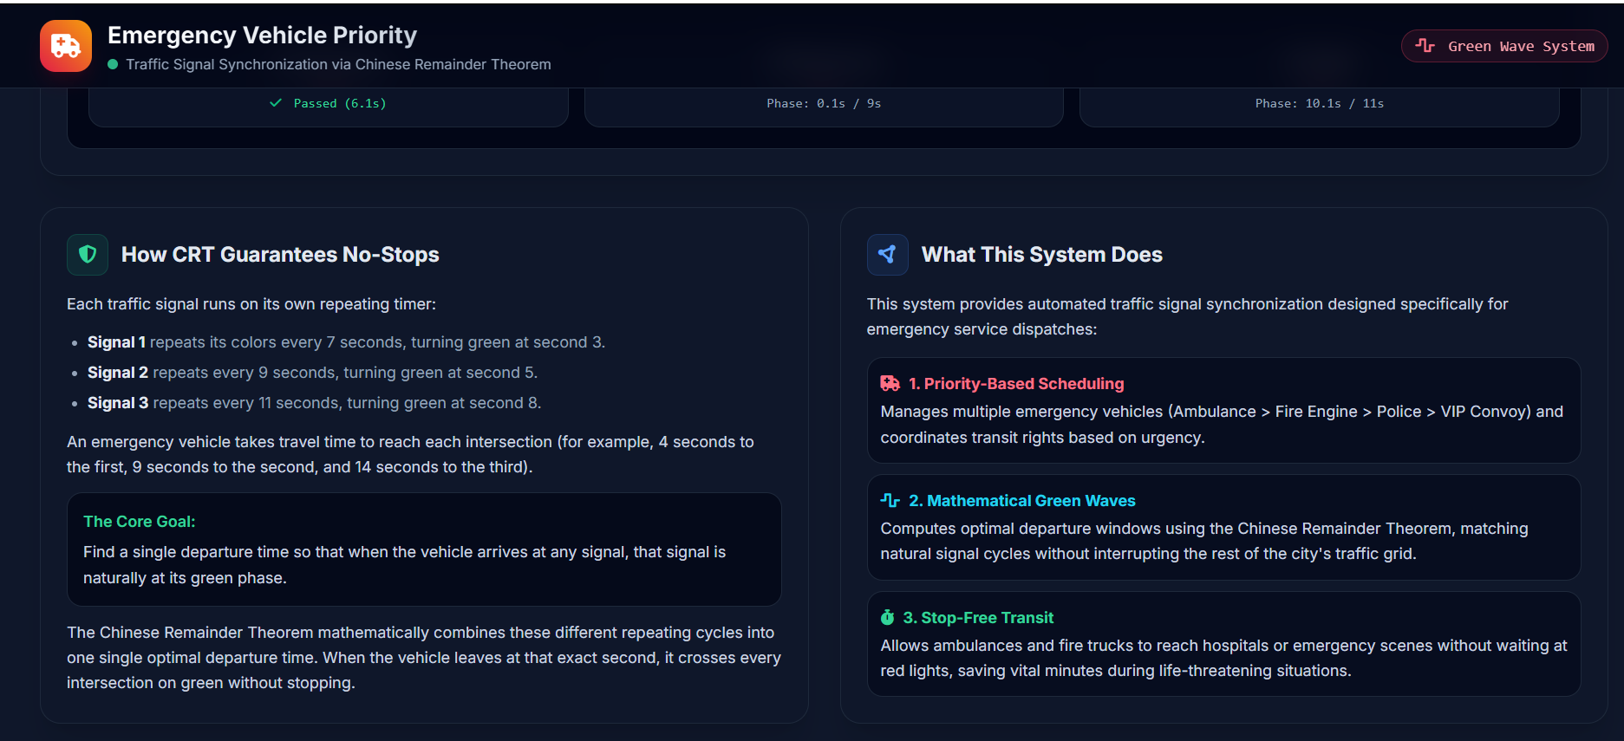

Chapter 6 : Conclusion

This Project-Based Learning study successfully conceptualized, formalized, and implemented a discrete mathematical priority system for emergency vehicles operating across cyclic urban traffic signal networks. By re-imagining periodic traffic lights as modular congruences and leveraging the analytical power of the Chinese Remainder Theorem, the system establishes a deterministic green corridor that fundamentally minimizes emergency transit delays and eliminates hazardous red-light halts.
Through Python implementation utilizing the Extended Euclidean Algorithm, the model proves that optimal progression timings can be computed instantaneously with minimal overhead. Furthermore, by identifying explicit limitations—including the necessity of coprime cycle lengths, external vehicle sensing, and dynamic queue variations—this report establishes a rigorous baseline for future intelligent transportation systems. Integrating CRT-based synchronization with modern Vehicle-to-Infrastructure (V2I) communication protocols and real-time GPS speed adaptation promises to provide a highly scalable, mathematically grounded solution to urban emergency transit logistics.

References
[1] Rosen, K. H. (2019). Discrete Mathematics and Its Applications (8th ed.). McGraw-Hill Education. [Chapter 4: Number Theory and Cryptography, pp. 278-285].
[2] Gartner, N. H., Pooran, F. J., & Andrews, C. M. (2002). Implementation of the OPAC Adaptive Control Strategy in a Traffic Network. IEEE Transactions on Intelligent Transportation Systems, 3(4), 283-290.
[3] Federal Highway Administration (FHWA). (2008). Traffic Signal Timing Manual. U.S. Department of Transportation, Report No. FHWA-HOP-08-024.
[4] Koonce, P., & Rodegerdts, L. (2010). Signal Timing Manual. Transportation Research Board, National Cooperative Highway Research Program (NCHRP Report 812).
[5] Cormen, T. H., Leiserson, C. E., Rivest, R. L., & Stein, C. (2009). Introduction to Algorithms (3rd ed.). MIT Press. [Section 31.5: The Chinese Remainder Theorem].
[6] Python Software Foundation. (2026). Mathematical Functions and Number Theory Documentation (Python 3.12 Standard Library).

Annexure 1
GitHub Upload screenshot
Repository URL: https://github.com/Sanjivani-COE-Comp/CRT-Emergency-Vehicle-Signal-Priority
The complete Python source code, simulation test cases, modular congruence verification scripts, and documentation have been uploaded to the institutional GitHub repository.
[ Paste GitHub Repository Upload Screenshot / Commit History Here ]

Annexure 2
Presentation Geo Tag Photo
Institutional Location: Sanjivani College of Engineering, Kopargaon (Autonomous).
Classroom / Lab: Department of Computer Engineering (S.Y. B.Tech Lab 04).
[ Paste Presentation Geo-Tagged Photograph with Faculty Guide Here ]

Annexure 3
Certificate of online Course related to Discrete Mathematics Course
Course Title: Discrete Mathematics / Number Theory in Computing (NPTEL / Coursera / Swayam).
Candidate: Sonawane Sakshi Sampat & Team Members.
[ Paste Certified Online NPTEL / Course Certificate Here ]

